SIMATS ENGINEERING
ASSESSMENT TOOL 3

COURSE NAME: Database Management Systems COURSE CODE: CSA05

COURSE OUTCOME COVERED

CO4: Design database solutions incorporating file organization, indexing, and hashing techniques to optimize data storage and retrieval efficiency. (BL3, BL4)
Activity Tool : Comparative Analysis (Low) Assessment Tool Weightage: 10%

QUESTIONS
Q.No | Question | Bloom's Level
1 | Compare sequential file organization and heap file organization in terms of data insertion, deletion, and retrieval efficiency. | Bloom’s Level: 4 – Analyze
2 | Differentiate between clustered indexing and non-clustered indexing with suitable database examples. | Bloom’s Level: 4 – Analyze
3 | Compare primary indexing and secondary indexing based on storage requirements and search performance. | Bloom’s Level: 4 – Analyze
4 | Analyze the differences between static hashing and dynamic hashing in database systems. | Bloom’s Level: 4 – Analyze
5 | Compare B-Tree indexing and B+ Tree indexing for large-scale database applications. | Bloom’s Level: 4 – Analyze
6 | Differentiate linear hashing and extendible hashing in terms of bucket management and scalability. | Bloom’s Level: 4 – Analyze
7 | Compare dense indexing and sparse indexing with respect to memory usage and access speed. | Bloom’s Level: 4 – Analyze
8 | Analyze the advantages and limitations of indexed sequential file organization versus direct file organization. | Bloom’s Level: 4 – Analyze
9 | Compare single-level indexing and multi-level indexing for efficient database retrieval operations. | Bloom’s Level: 4 – Analyze
10 | Evaluate the performance of hashing techniques and indexing techniques for exact-match and range queries in databases. | Bloom’s Level: 5 – Evaluate

Code of Conduct:

I JEROLD SAMUEL J (192571052)certify that this submission is my original work and that I have adhered to the guidelines specified for this assessment.
I understand that any violation of academic integrity rules will result in disciplinary action.

Signature of the student:
JEROLD SAMUEL J

Q1. Compare Sequential File Organization and Heap File Organization in Terms of Data Insertion, Deletion, and Retrieval Efficiency

Feature | Sequential File Organization | Heap File Organization
Storage Method | Records stored in sorted order of key | Records stored in no particular order
Insertion | Slow, may require shifting records | Fast, inserted at end of file
Deletion | Costly, may require reorganization | Easy, record can be marked deleted
Retrieval | Very efficient for sequential/range search | Requires linear search
Maintenance | High maintenance | Low maintenance
Example | Banking records sorted by account number | Log files and transaction records

Conclusion: Sequential files are suitable for frequent searching and reporting, whereas heap files are preferred when insertions occur frequently.

Q2. Differentiate Between Clustered Indexing and Non-Clustered Indexing with Suitable Database

Feature | Clustered Index | Non-Clustered Index
Data Storage | Data physically stored in index order | Index stored separately from data
Number per Table | Only one | Multiple allowed
Search Speed | Faster for range queries | Faster for specific lookups
Storage Overhead | Less | More
Example | Student table sorted by Roll No | Index on Student Name
Example:



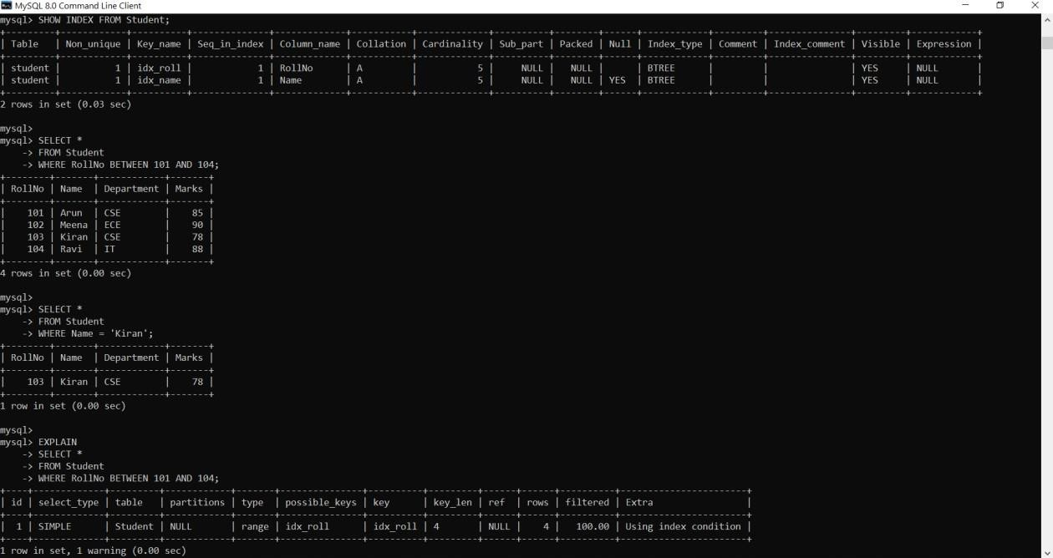

Conclusion: Clustered indexing improves range-based retrieval, while non-clustered indexing supports multiple search attributes.

Q3. Compare Primary Indexing and Secondary Indexing Based on Storage Requirements and Search Performance

Feature | Primary Index | Secondary Index
Based On | Primary key | Non-key attribute
Storage Space | Less | More
Number Allowed | One | Multiple
Search Performance | Very fast | Fast but requires extra access
File Ordering | Data file sorted on primary key | Data file need not be sorted

Example:
- Primary Index on StudentID
- Secondary Index on Department

Conclusion: Primary indexing requires less space and offers better performance, while secondary indexing provides flexible access paths.

Q4. Analyze the Differences Between Static Hashing and Dynamic Hashing in Databases

Feature | Static Hashing | Dynamic Hashing
Bucket Count | Fixed | Variable
Overflow Handling | Overflow chains | Bucket splitting
Performance | Degrades as file grows | Maintains efficiency
Memory Usage | Fixed | Dynamic
Scalability | Poor | Excellent

Example:
Static Hash Function h(key)=key mod 10
Dynamic Hashing
- Extendible Hashing
- Linear Hashing
Conclusion: Dynamic hashing is better for growing databases due to automatic expansion.

Q5. Compare B-Tree Indexing and B+ Tree Indexing for Large-Scale Database Applications

Feature | B-Tree | B+ Tree
Data Storage | Internal and leaf nodes | Only leaf nodes
Search | Faster for exact search | Better for range queries
Sequential Access | Difficult | Easy through linked leaves
Fan-Out | Lower | Higher
Database Usage | Less common | Widely used

Example:
Databases such as MySQL and Oracle use B+ Trees for indexing.

Conclusion: B+ Trees are preferred because they provide efficient searching and range query performance.

Q6. Differentiate Linear Hashing and Extendible Hashing in Terms of Bucket Management and Scalability

Feature | Linear Hashing | Extendible Hashing
Directory | Not required | Required
Expansion | Gradual bucket split | Directory doubling
Memory Overhead | Low | Higher
Search Speed | Good | Very Good
Scalability | High | Very High

Example:
- Linear Hashing splits buckets sequentially.
- Extendible Hashing doubles directory size when overflow occurs.

Conclusion: Extendible hashing provides better lookup performance, while linear hashing uses less memory.

Q7. Compare Dense Indexing and Sparse Indexing with Respect to Memory Usage and Access Speed.
Feature | Dense Index | Sparse Index
Index Entries | One entry per record | One entry per block
Memory Requirement | High | Low
Search Speed | Faster | Slightly slower
Maintenance Cost | High | Low
Storage Overhead | Large | Small

Example:
Dense Index
- 101 → Block1
- 102 → Block2
- 103 → Block3 Sparse Index
- 101 → Block1
- 201 → Block2
- 301 → Block3

Conclusion: Dense indexing offers faster access but consumes more storage, while sparse indexing saves space.

Q8. Analyze the Advantages and Limitations of Indexed Sequential File Organization Versus Direct File Organization

Feature | Indexed Sequential | Direct File Organization
Access Type | Sequential and random | Direct/random
Search Speed | Fast | Very fast
Range Queries | Supported | Poor support
Storage Overhead | Requires index | No index needed
Maintenance | Moderate | Complex hashing management

Advantages of Indexed Sequential • Supports range queries.
- Sequential processing possible.
Limitations
- Extra index storage.
- Index maintenance required.
Advantages of Direct File Organization • Very fast exact record retrieval.
- Suitable for transaction processing.
Limitations
- Poor for range searches.
- Overflow handling needed.

Conclusion: Indexed sequential files are better for reporting, whereas direct files are suitable for OLTP systems.

Q9. Compare Single-Level Indexing and Multi-Level Indexing for Efficient Database Retrieval Operations

Feature | Single-Level Index | Multi-Level Index
Structure | One index file | Hierarchical indexes
Search Time | More for large files | Less
Storage | Less | More
Scalability | Limited | Excellent
Example | Small database | Large database

Example:

Single Level:
• Index → Records Multi Level:
Root Index
↓
Second Level Index
↓
Data Blocks

Conclusion: Multi-level indexing is preferred for large databases because it significantly reduces search time.

Q10. Evaluate the Performance of Hashing Techniques and Indexing Techniques for Exact-Match and Range Queries in Databases
Criteria | Hashing | Indexing
Exact Match Search | Excellent O(1) | Good O(log n)
Range Queries | Poor | Excellent
Ordered Data | Not maintained | Maintained
Insert Performance | Fast | Moderate
Storage Overhead | Low | Higher

Example:

Hash Search
- h(105)=5 Index Search
- B+ Tree Search
- 105 → Leaf Node
Evaluation
- For exact record retrieval, hashing performs best.
- For range queries and sorted access, indexing performs best.

Conclusion: Hashing is ideal for equality searches, while indexing (especially B+ Trees) is preferred for range-based retrieval and analytical workloads.

